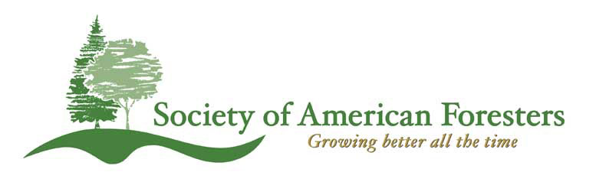

November 30, 2012

Dear Norm Dicks, etc, etc

Representing the Washington State Society of American Foresters, I want to take this opportunity to recognize your efforts regarding HB 5995, The Wild Olympics and Wild and Scenic Rivers Act of 2012. WSSAF represents over 560 natural resource professionals in Washington State. Our mission in part is to “Use the knowledge, skills and conservation ethic of the profession to ensure the continued health and use of forest ecosystems and the present and future availability of forest resources to benefit society”. To that end our membership has prepared and adopted Position Statements that are relevant to the expansion of wilderness and wild and scenic rivers designations within the Olympic National Forest. I have attached two Statements:

Revision of the Olympic National Forest Plan, adopted, July 23, 2009

Working Forest Position Statement, adopted, August 10, 2011

The Olympic National Forest Statement urges “land use allocations on the Olympic National Forest to include a mix of allocations that are consistent with multiple use requirements of the National Forest Management Act” that encourages timber harvest and forest land use on a sustained yield basis.

Working Forests are defined in that Position Statement as

“….a forest that is actively managed for a sustainable and balanced delivery of social, ecological, and economic products and values.”

Further, Active Management is defined as

“…silvicultural practices ….that happen recurrently and perpetually over most of the forestland area…”

It is critical that land use policies recognize the multiple values of working forests and “respect the rights and responsibilities of ---public forest landowners.”

The lack of Matrix (Working Forests) on the Olympic National Forest is counter to our positions and counter to providing a balance of social, economic and ecologic benefits. Forest Service land use decisions should provide the greatest amount of good for the greatest amount of people in the long run. HB 5995 does not to do that,

We urge you to incorporate our positions, and the economic, social and environmental benefits of sustained forest management on the Olympic Peninsula when considering HB 5995.

Sincerely,

Tom Hanson, WSSAF Chair -2012

